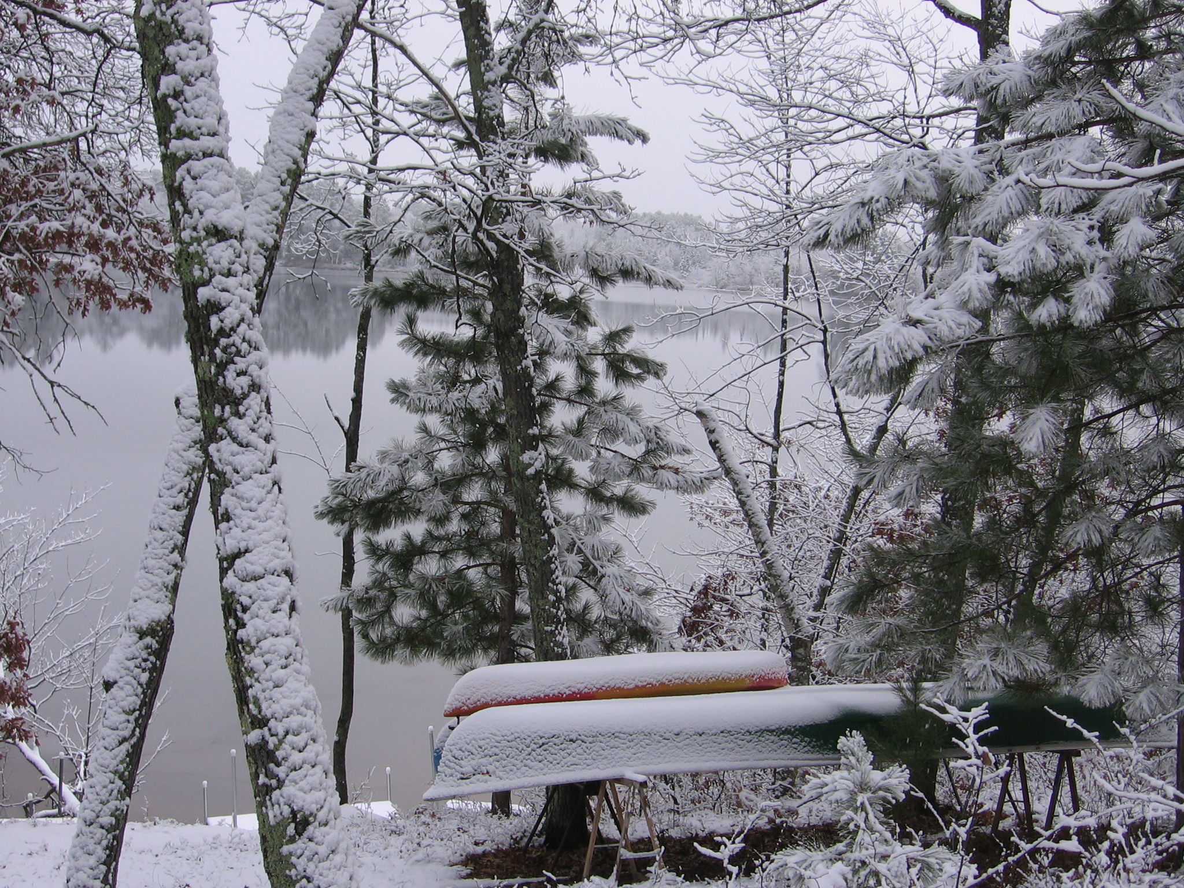 | Red Lake Association  Wascott, Wisconsin
Winter 2007 Volume 2, Number 1

In This Issue  - Our Mission  - Next meeting scheduled  - Member Roster  - Annual Meeting Summary  Category of Links  Red Lake Association  or http://www.pressenter.com/~rla/  Links.htm  Wisconsin Association of Lakes  or  http://www.wisconsinlakes.org/  Douglas County Association of Lakes and Streams  or http://www.fotsch.org/DCALS.htm  Contact Us  tom.mahoney@  millennialeaders.com  715/466-5951  Water Quality Committee  Tom Johnson, Chair  Tom Mahoney  Leeann Pollock  Jeff Robinson  Membership Committee  LeeAnn Pollock, Chair  Joel Skinner  Grant Writing Committee  Mary Mahoney, Chair  Carol Skinner  Check out the Red Lake Association Website  Red Lake Association  or http://www.pressenter.com/~rla/  Links.htm  Remember to Attend:  Red Lake Association Annual Meeting - May 26, 2007 9am  Scott Toshner – DNR Fishery Manager will present  Summer meeting - August 18, 2007 9am  Wascott Town Hall  Newsletter by Tom Mahoney  Please send any comments or ideas to:tom.mahoney@millennialeaders.com  16242 S. Ahrens Dr., Minong, WI 54859  715/466-5951 | Red Lake Association news  The Red Lake Association’s (RLA) first annual meeting was held on June 10th at the Wascott Town Hall. See meeting summary inside.  Board members are:  President: Tom Mahoney  Vice President: Brad Guinn  Treasurer: Mary Jane Wesolowski  Secretary: Carol Skinner  Members At Large: Patrick Daly, Bev Robinson, Leeann Pollack, Barb Johnson  Annual membership dues are $25 per family. Dues for 2007 are due now. If you haven’t sent in your payment, please do so and send it to Mary Jane Wesolowski at 16242 S. Ahrens Dr., Minong, WI 54859.  Our Mission  The purpose of the Association is to preserve and protect Red Lake in Wascott, Wisconsin and its surroundings, and to enhance the water quality, fishery, boating safety, and aesthetic values of Red Lake, as a public recreational facility for today and for future generations.  Next Meeting Scheduled for May 26th  Wascott Town Hall 9am  The next annual meeting of the Red Lake Association has been scheduled for May 26th at 9am. The meeting will be held at the Wascott Town Hall.  Agenda  Introduce members & board  Presentation by Scott Toshner – DNR Fishery Manager – discuss stocking and shocking of Red Lake and related topics.  Business meeting  Committee reports  New Business - budget, planning, membership  Member Roster  The following families are members. Dues are $25 per family for the year. 2007 dues are now due.  Ahrens Jr., Robert & Pat  Arneson, Earl & Donna  Bailey, Jim & Mary Jane  Bauers, Gene & JoAnn  Braden, David & Ann  Buettner, Gary & Mae  Carpentier, Bill (Carp) & Sue  Chase, James & Bonnie  Coenen, Richard & Frances  Dahl, Rita & Barry Nab  Daly, Tom & Shirley & Patrick  Donovan, James & Myrna  Eisele, Gregory & Sharon  Frye, Jim & Dolly  Guinn, Brad  Hero, Frances & Stephen  Hollingsworth, Lee & Carla  Jochims, Bob  Jochims, Jim & Marilyn  Jochims, Neil & Kathy  Johnson, Tom & Barb  Kennedy, John  Knabe, Jeanette & George  Kopfman, Edward & Ann  Lynn, Chester & Vi  Mahoney, Tom & Mary  Pimple, Thomas & Shirley  Pollock, Matt & Lee Ann  Post, Scott & Julie  Rathke, Jarold & Sharon  Robinson, Jeff & Beverly  Rodemann, Bill & Lynn  Sandstrom, Dean  Santangelo, Ray & Bobbie  Skinner, Joel & Carol  Wecker, Dihl & Ruth Ann  Wesolowski, Wes & Mary Jane  Wigstrom, Tom & Sally

Red Lake Association Meeting of August 2006 - Summary

A regular meeting of the Red Lake Association was held on August 19, 2006, at the Wascott Town Hall in Wascott, WI. The meeting was called to order at 9:00 am.

The minutes from the annual meeting, held in June, were presented. Motion was made and seconded to approve the minutes in their current form. Motion carried.

The treasurer’s report was given by Treasurer Mary Jane Wesolowski showing a current balance of $491.51.

Membership was discussed. Currently 70% of lake residents are members. Effort will be made to contact the remaining 30% to try to get 100% ownership.

The association’s website has been up and running for six months. Free service has been provided by a River Falls company. Joel Skinner discussed specifics.

Discussion of number of signatures required to write checks and withdraw money. There is currently one. Motion was made to require two signatures for checks and withdrawals over $100. Motion carried.

Discussion of notifying residents of the annual boat parade on July 4th. It will start at noon at the north end of the lake. The Board will put information about it in the newsletter and discuss it further at the annual meeting (Saturday of Memorial Day weekend, May 26, 2007).

There was consensus about putting up a notice to lake users regarding:
- Skiing only between 10:00 am and 7:00 pm
- No soap bathing in the lake
- Keeping a healthy distance from other boats
- High speeds in middle of lake, but not near the shore
- No littering in lake or boat landing area

Discussion regarding the Town of Wascott Ordinance regarding Water Traffic, Boating and Water Sports upon all Wascott Lakes. Summary provided below.

Motion made and carried for having the fiscal year equivalent to the calendar year.

Motion made and carried for the RLA annual meeting to be held the Saturday of Memorial Day weekend, and a regular meeting on the 3rd Saturday in August.

Discussion of notifying residents of the annual boat parade on July 4th. It will start at noon at the north end of the lake. The Board will put information about it in the newsletter and discuss it further at the annual meeting (Saturday of Memorial Day weekend – May 26, 2007).

Town of Wascott Ordinance regarding Water Traffic, Boating and Water Sports upon all Wascott Lakes. (summarized below – available at Town Hall #3-81, Amended #1-85)

Speed Restrictions – No person shall operate a motor boat at a speed greater that is reasonable and prudent under the conditions and having regard for the actual and potential hazards that are existing.

Fixed Limits - No person shall operate a motor boat in excess of twelve (12) miles per hour before 9am or after 7pm.

Water Skiing, Tubing and Jet Skiing – prohibited before 9am or after 7pm, at least two persons over 12 years old must be in the boat and the driver must be at least 16 years old. Not to be operated within 100 feet of any dock, raft, occupied anchored boat, boat landing or other watercraft such as canoe or kayak.

Littering Waters Prohibited. No person shall deposit or throw from any boat, pier, dock or platform any cans, papers, bottles, debris, refuse, garbage – solid or liquid, into the waters of any lakes within the jurisdiction of the Town of Wascott.

Penalties – any person who violates the ordinance summarized above will upon conviction pay the penalties prescribed by the ordinance.

Common Courtesy – be respectful of those fishing, leave adequate space between your watercraft and the anglers. Be considerate of other watercraft towing skiers and tubers. Plan turns so as to not cut off other boats. Jet skiers – please realize the noise jet skis make. Many people enjoy the quiet and tranquility that our lake and woods has to offer.

Please be reminded that these laws are for the protection of all citizens and shall be enforced by officers of the town, county and state. Periodic checks of the lake are routine and officers will respond when called.

Announcements

Summer meeting August 18th, Wascott Town Hall @ 9am

Northwest Lakes Conference, Friday June 25th 8:30 – 4:30 at Telemark Conference Center in Cable. Sponsored by the lakes and rivers associations of Bayfield, Burnett, Douglas, Sawyer and Washburn Counties, the Wisconsin Association of Lakes, and the University of Wisconsin-Extension.

Links for information about the conference:
http://207.21.241.161/events/NWLC04.htm or www.wisconsinlakes.org

Information about Wisconsin Association of Lakes
Wisconsin Association of Lakes
One Point Place, Suite 101
Madison, WI 53719-2809
(608) 662-0923 or (800)-542-5253 (in WI) Phone

